Sensitivity Analysis
This analysis explores the sensitivity of key parameters affecting rabies epidemiology, including Mass Dog Vaccination (MDV), Human-Dog Ratio (HDR), and health-seeking behaviour (pSeek, pStart, and pComplete). Unless otherwise specified (eg a combination of MDV and HDR), each parameter is analyzed independently, meaning all other parameters are held constant while the parameter of interest is varied. For example, MDV coverage is explored across a range of 0% to 100%.
All plots present the median values with 95% confidence intervals (CI) based on 1,000 iterations of the stochastic model. These have been run over a horizon of 7 years and a human population of 600,000.

Mass Dog Vaccination (MDV) Sensitivity Analysis
This section evaluates the impact of varying MDV coverage on rabies epidemiology, including:
i) Rabid dog population; ii) Exposures; iii) Healthy bites; iv) Rabies deaths & v) Deaths averted due to MDV interventions

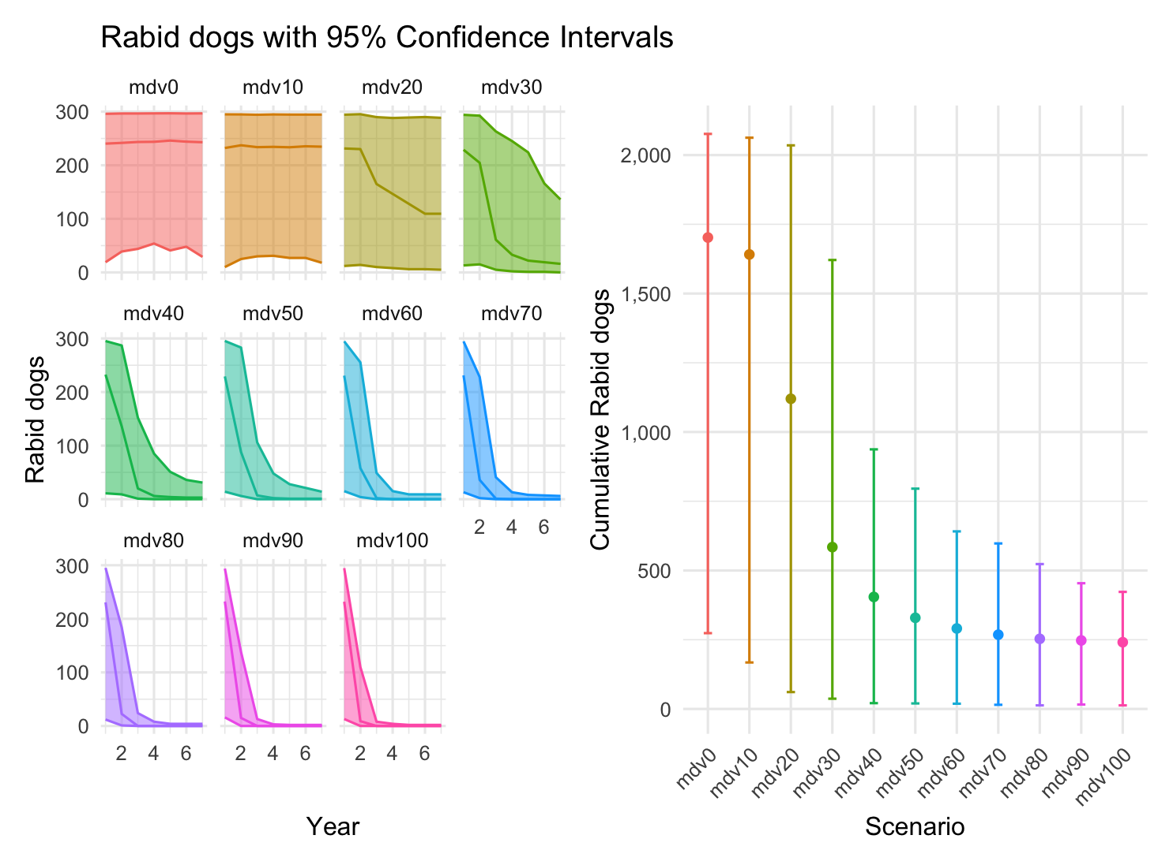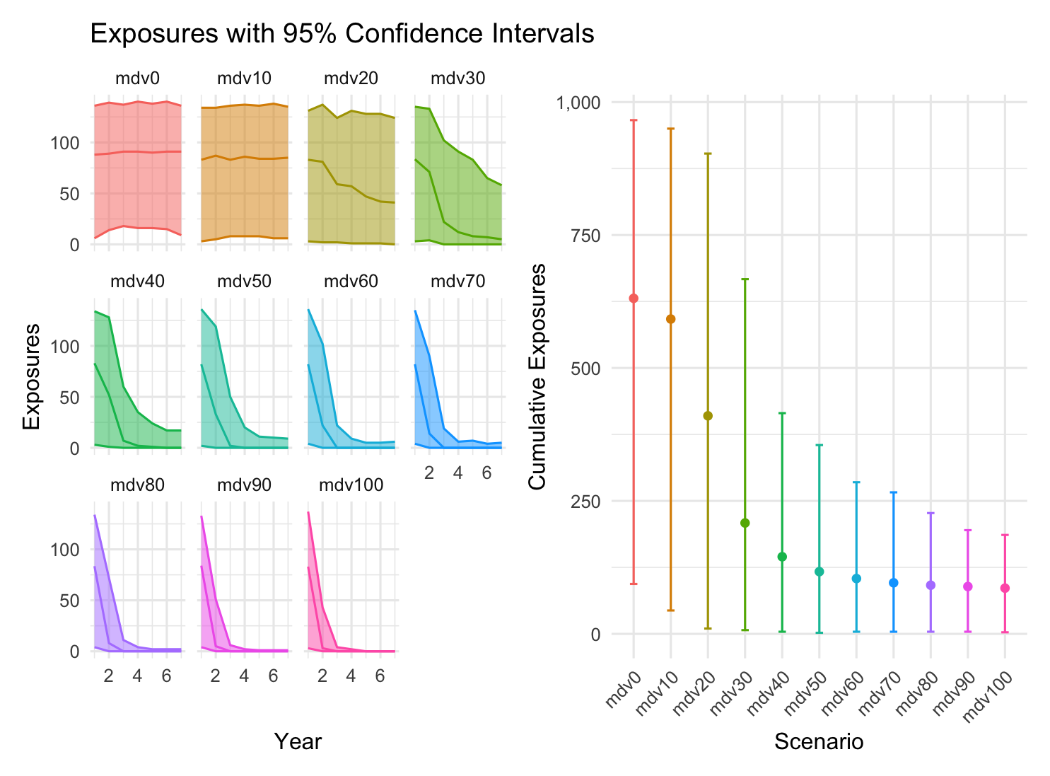

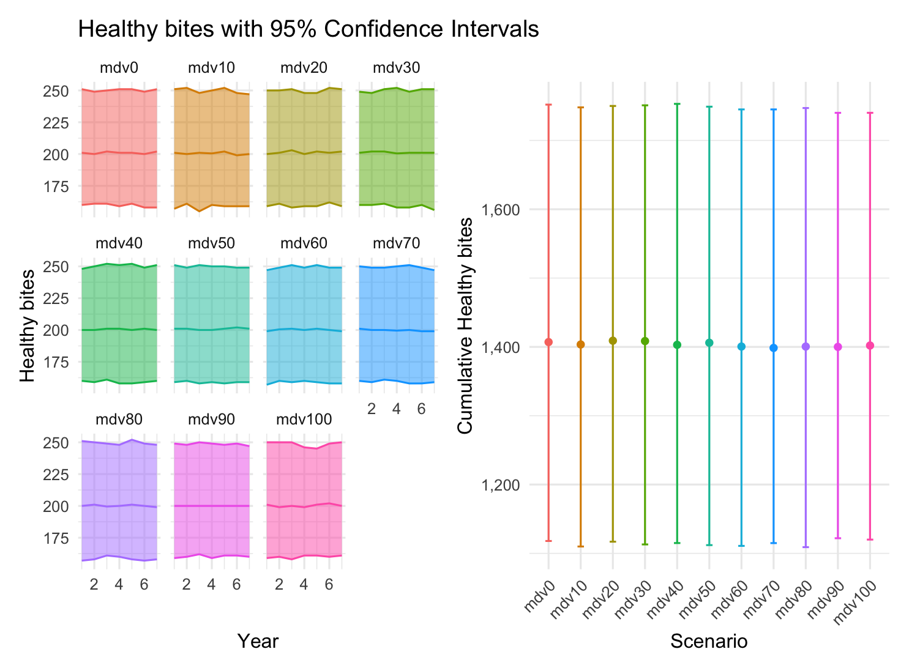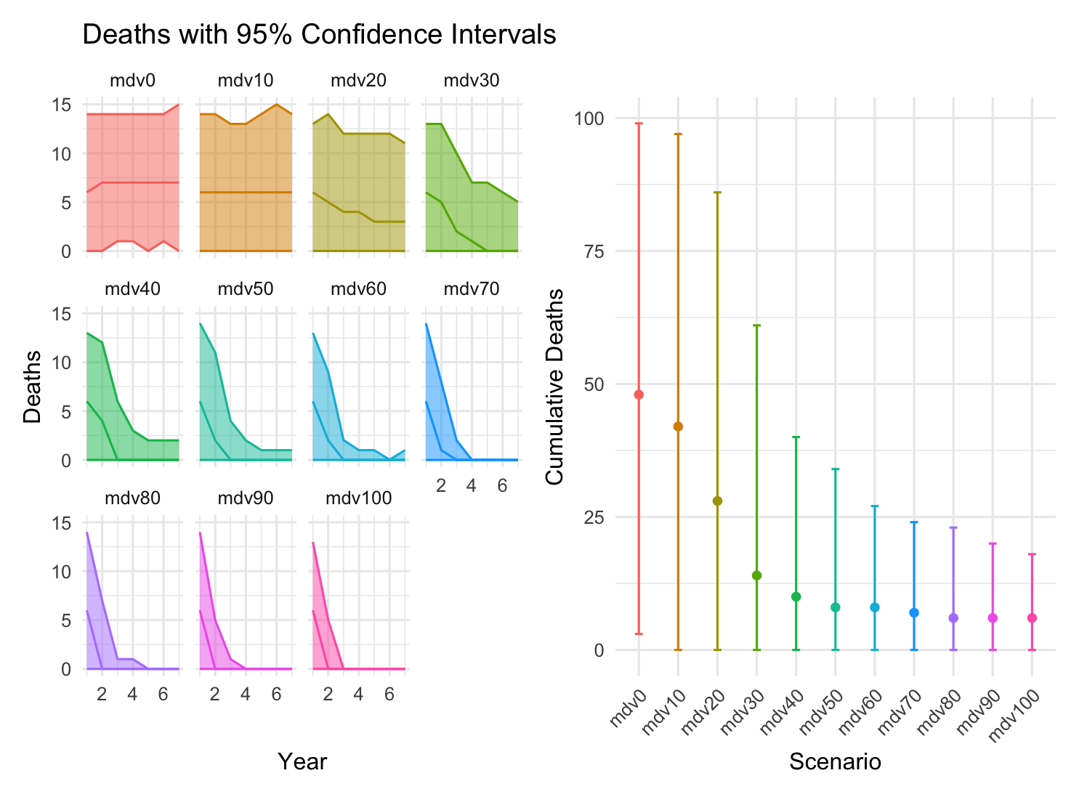
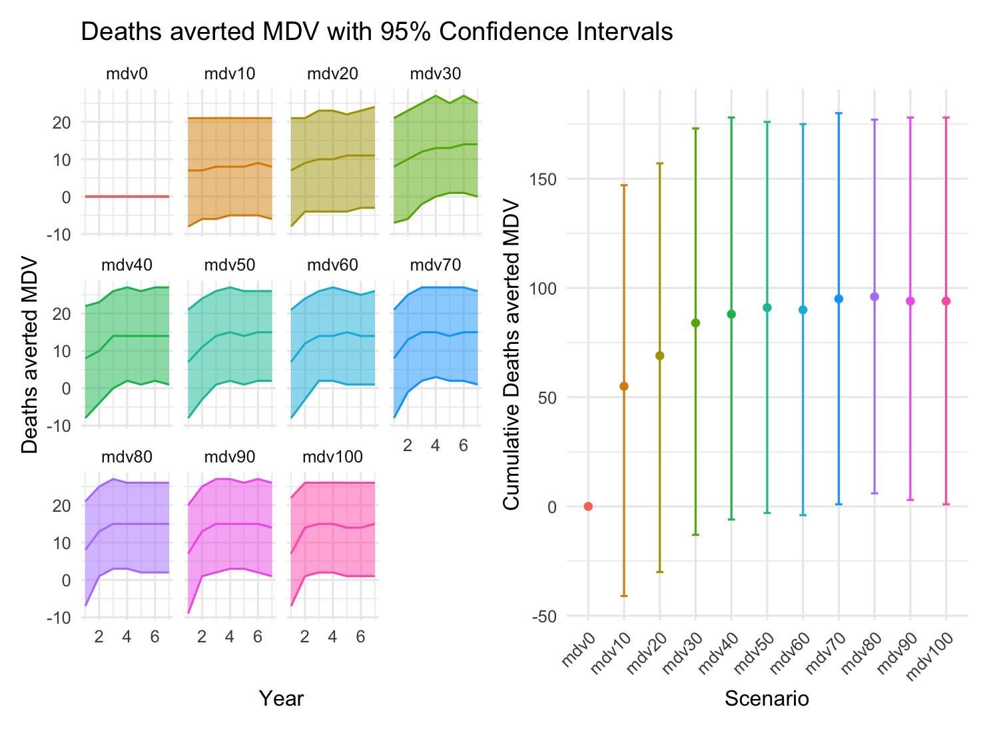

Human-Dog Ratio (HDR) Sensitivity Analysis
Sensitivity Analysis of HDR to rabid dogs, exposures, healthy bites & deaths incurred

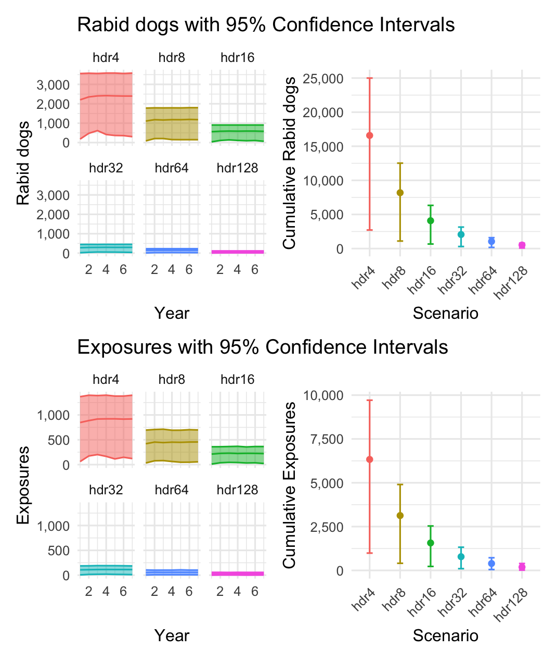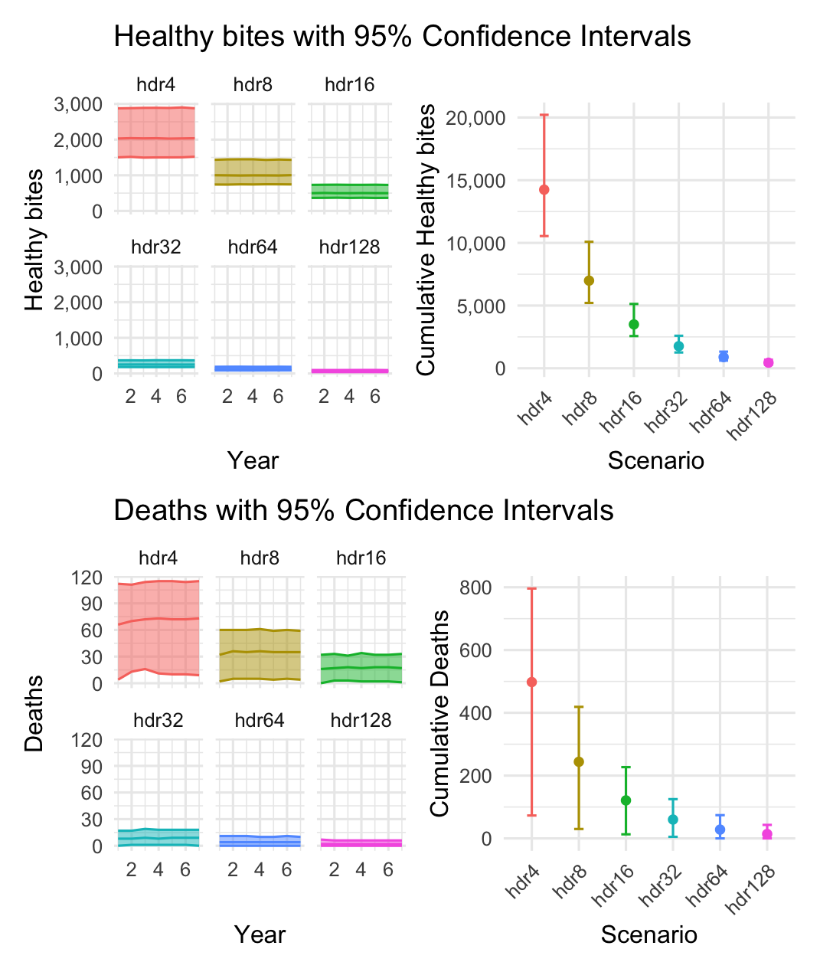

A combination of MDV and HDR
This generates interactive 3D plots, which I’ve then captured in png – html files available as attachments
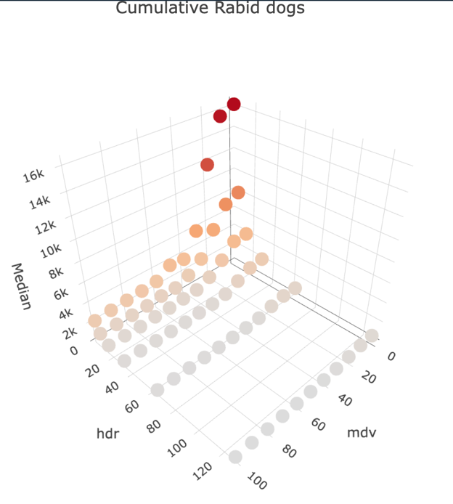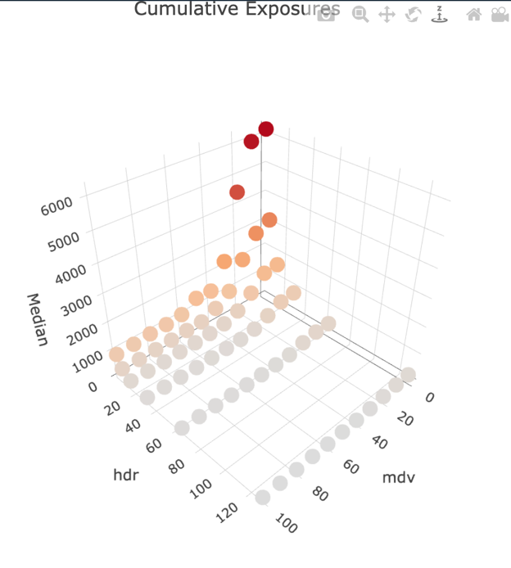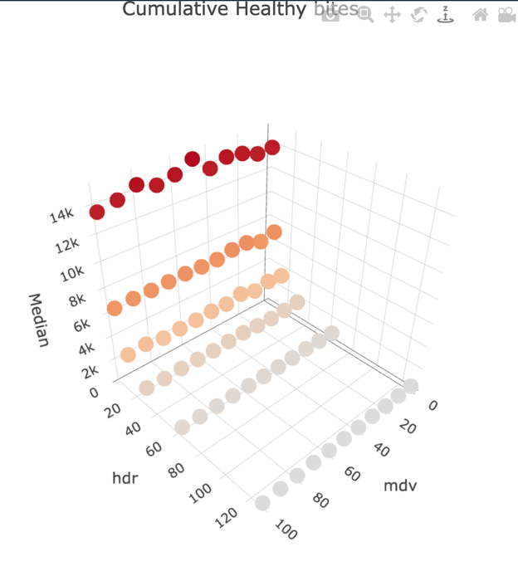
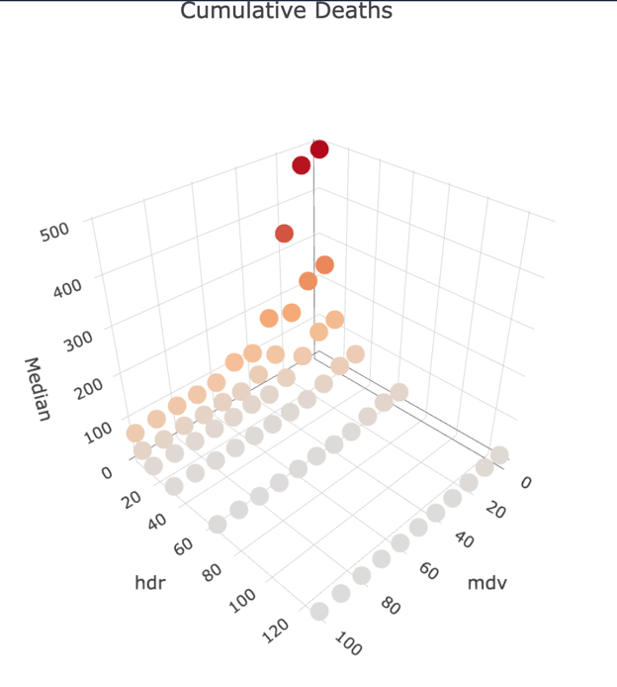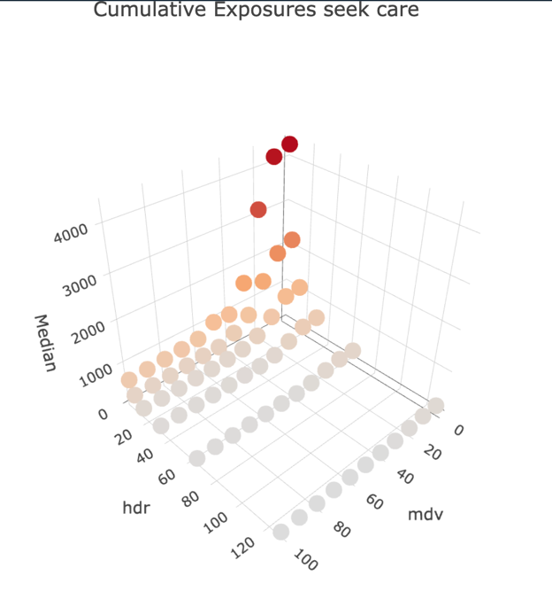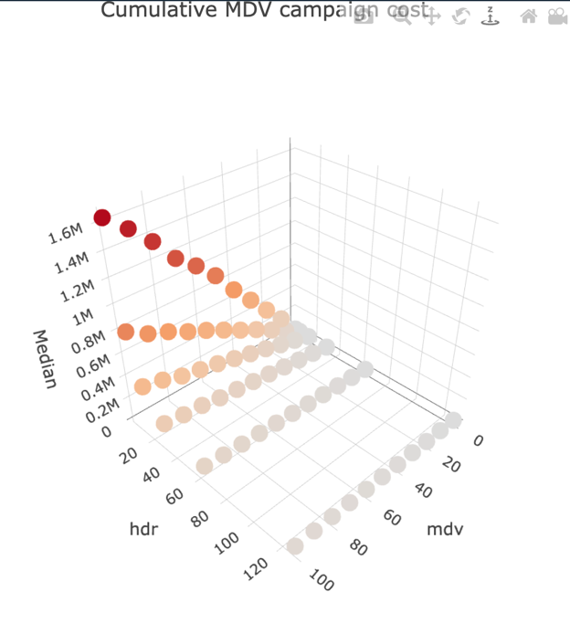

Healthcare seeking

pSeek
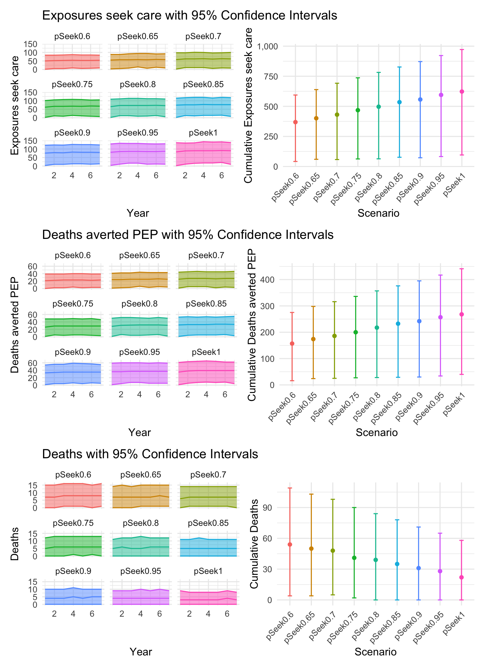

pStart
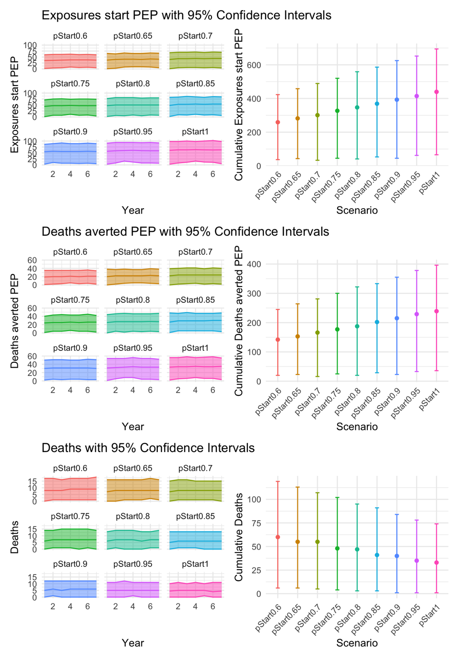

- pComplete
